**Bug Report**

Contents

**Bug-1** 1

**Bug-2** 2

**Bug-3** 3

**Bug-4** 4

**Bug-5** 6

**Bug-6** 6

## **Bug-1**

**Name/Summary:** Username and Password are not encrypted in the URL

**Project Name:** Programme Backlog

**Issue Type:** Bug

**Description:** username and password are displaying in clear text of the URL after login

**Priority:** High

**Severity:** 2-Major

**Steps to Reproduce:**

1. I am on login page from <http://54.253.214.197:8081>

2. I provide correct login credentials (e.g. username “ubiquity” and password “P@ss123#UbiQuity”)

3. Click on Login Button in the login page

**Expected Result:**

I should be direct to landing page without clear username and password

**Actual Result:**

I have been direct to landing page with username and password are displaying in the URL

**Asset:** Ubiquity Tester

**Assignee:**

**Reporter:** Whitney Li

**Environment:** test environment

**Versions:**

Release version – unknow

Browser - Google Chrome(86.0.4240.75) in windows10

**Attachments:**

Defect Image

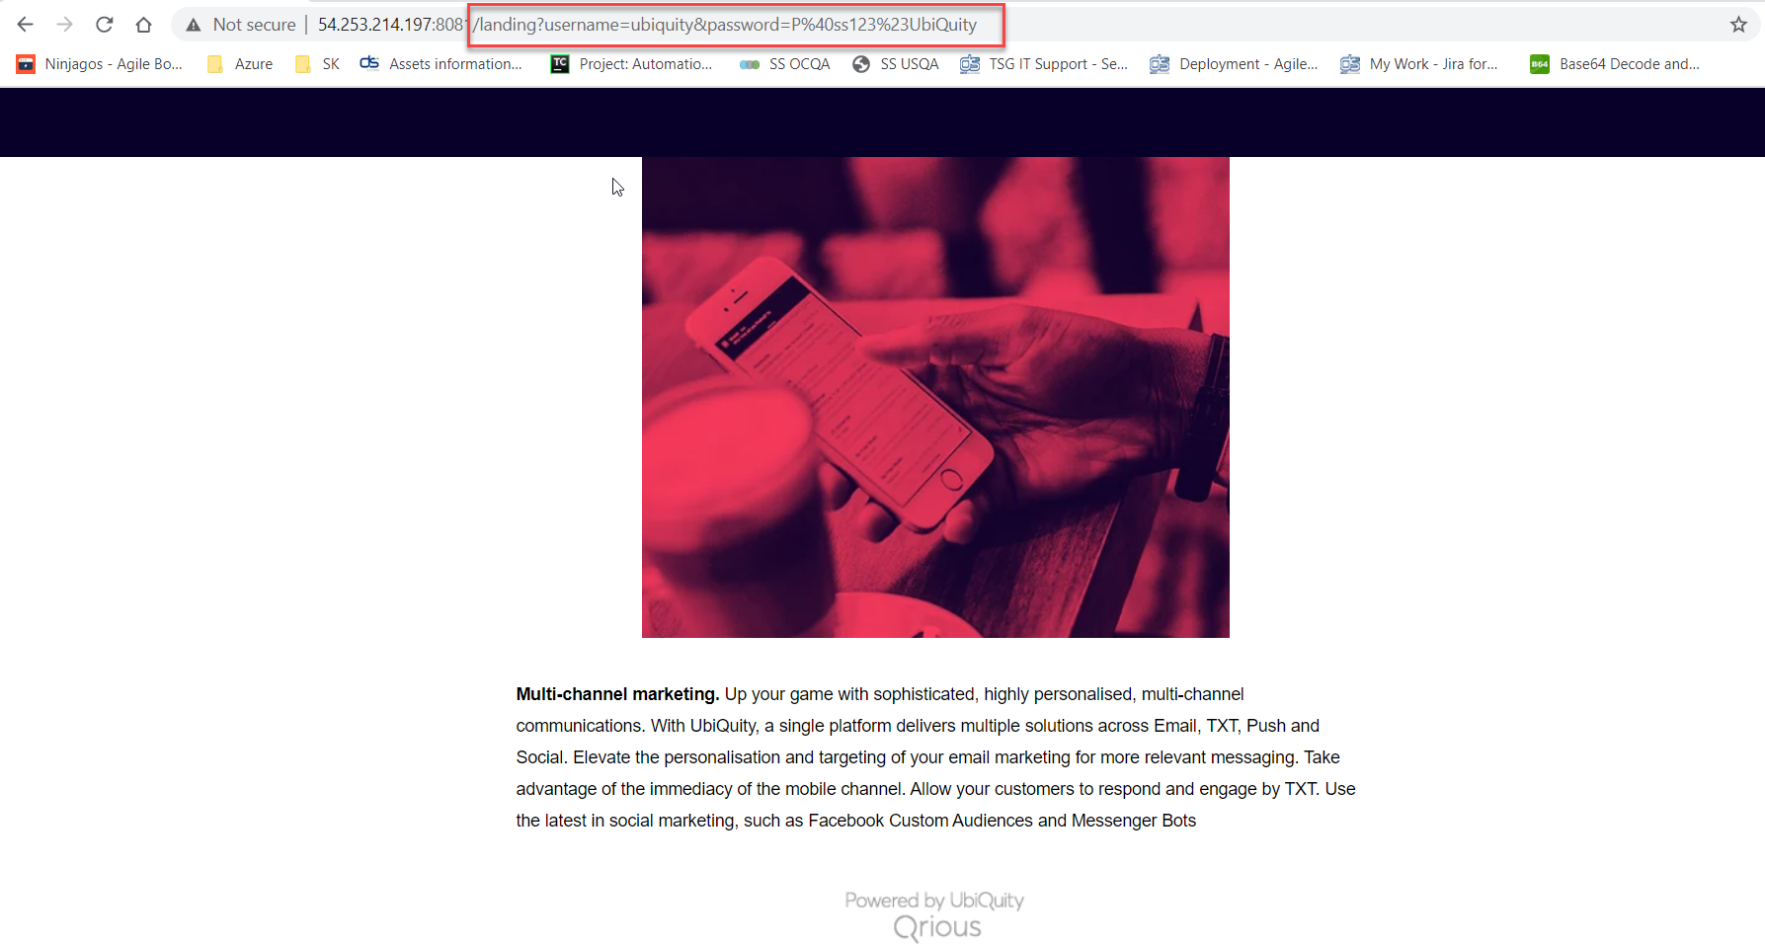

## **Bug-2**

**Name/Summary:** User should not be able to access landing page and Edit Profile page without login

**Project Name:** Programme Backlog

**Issue Type:** Bug

**Description:** User currently can access landing (<http://54.253.214.197:8081/index>) and Edit Profile(<http://54.253.214.197:8081/editprofile>) page without login(username and password)

**Priority:** High

**Severity:** 2-Major

**Steps to Reproduce:**

I am on browser and put the following URL <http://54.253.214.197:8081/index> or <http://54.253.214.197:8081/editprofile> in the address panel

**Expected Result:**

I should not be able to access the page as I did not provide login credentials

**Actual Result:**

I am able to access the details in welcome page: <http://54.253.214.197:8081/index> and Edit Profile page: <http://54.253.214.197:8081/editprofile>

**Asset:** Ubiquity Tester

**Assignee:**

**Reporter:** Whitney Li

**Environment:** test environment

**Versions:**

Release version – unknow

Browser - Google Chrome(86.0.4240.75) in windows10

## **Bug-3**

**Name/Summary:** User is not able to update any data under the account successfully

**Project Name:** Programme Backlog

**Issue Type:** Bug

**Description:** User is not able to update any data under the account successfully, even they can see the successful message but the data does not change after user back to edit profile page from other page(there is no request has been sent)

**Priority:** High

**Severity:** 2-Major

**Priority:** High

**Severity:** 2-Major

**Steps to Reproduce:**

Scenario 1 :

1. I am on Edit Profile page

2. I update Password successfully(to see the successful message “Update is successful! Please see updated information below” )

3. I Click on Logout button in Edit Profile page

4. After I am redirect to login page

5. Re-login with old username and new password

Scenario 2 :

1. I am on Edit Profile page

2. I update Email/Mobile/DateOfBirth successfully(to see the successful message “Update is successful! Please see updated information below” )

3. I Click on Home button on the Edit Profile page

4. I Click on Edit Profile button after I am been redirect to landing page from step3

**Expected Result:**

Scenario 1: I should be direct to landing page with new password

Scenario 2 : I should be able to see all the new data I have updated before

**Actual Result:**

Scenario 1: I am not able to login with new password and get error message “Incorrect username or password.”

Scenario 2 : I am still seeing the old data before I updated the profile

**Asset:** Ubiquity Tester

**Assignee:**

**Reporter:** Whitney Li

**Environment:** test environment

**Versions:**

Release version – unknow

Browser - Google Chrome(86.0.4240.75) in windows10

## **Bug-4**

**Name/Summary:** Ubiquity logo should appear on Home(landing) page

**Project Name:** Programme Backlog

**Issue Type:** Bug

**Description:** Ubiquity logo should appear on Home(landing) page when user login or back from EditProfile page

**Priority:** Medium

**Severity:** 3-Minor

**Steps to Reproduce:**

1. I am on login page from <http://54.253.214.197:8081>

2. I provide correct login credentials (e.g. username “ubiquity” and password “P@ss123#UbiQuity”)

3. I Click on Login Button in login page

**Expected Result:**

I should be direct to landing page and see Ubiquity logo at the top left

**Actual Result:**

I have been direct to landing page and there is no Ubiquity logo at the top left

**Asset:** Ubiquity Tester

**Assignee:**

**Reporter:** Whitney Li

**Environment:** test environment

**Versions:**

Release version – unknow

Browser - Google Chrome(86.0.4240.75) in windows10

**Attachments:**

Expected Result

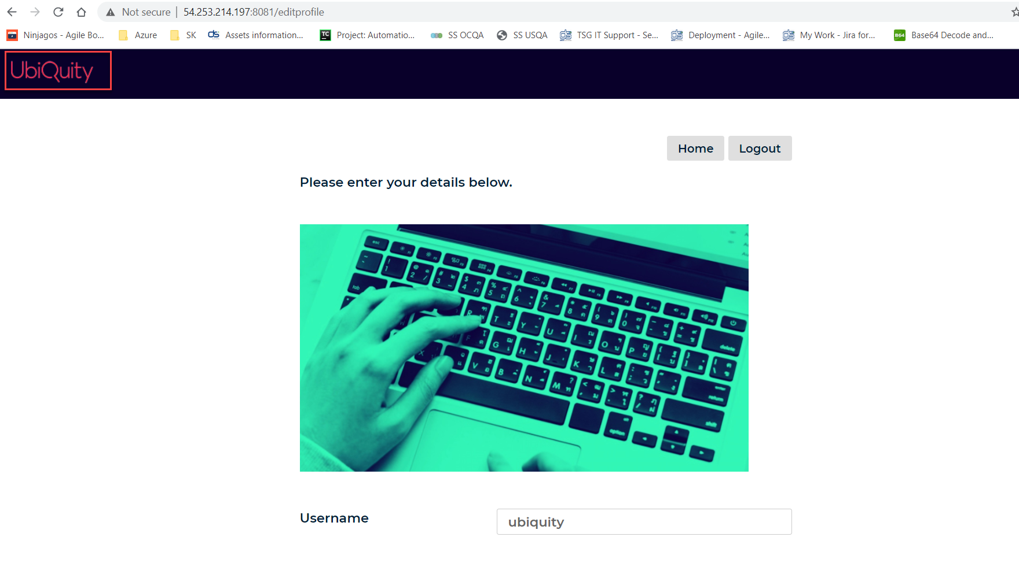

Actual Result

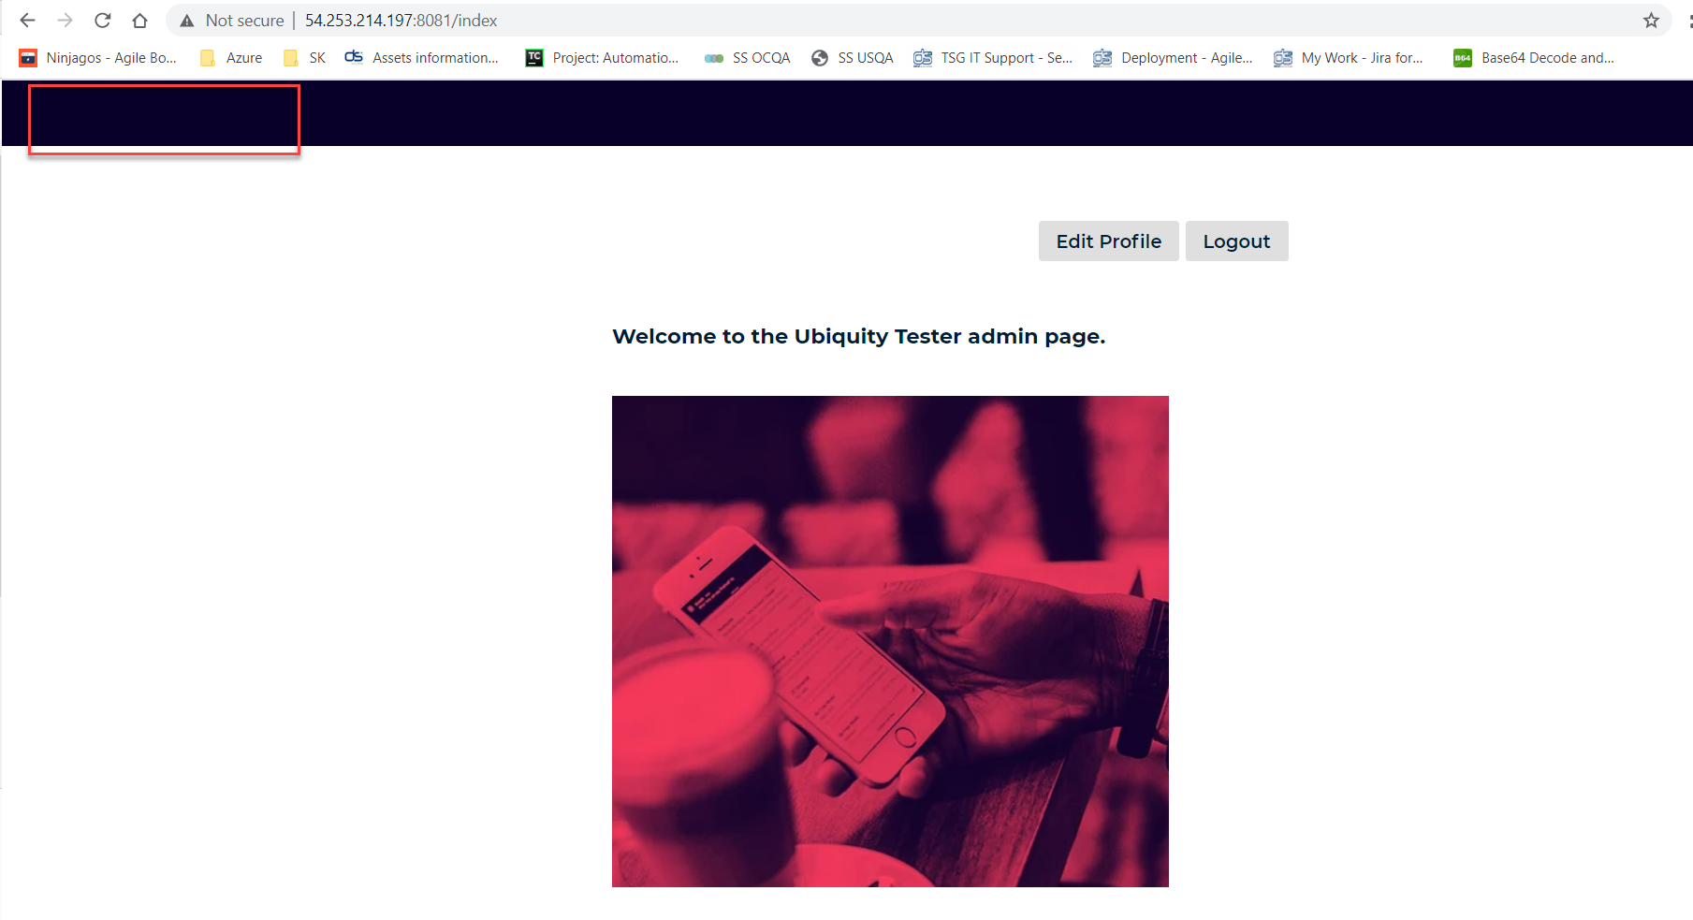

## **Bug-5**

**Name/Summary:** There are no validation for Mobile and DateOfBirth in Edit Profile

**Project Name:** Programme Backlog

**Issue Type:** Bug

**Description:** There is no validation for Mobile and DateOfBirth after clicking Submit button on Edit Profile page

**Priority:** Low

**Severity:** 3-Minor

**Steps to Reproduce:**

Scenario 1 :

1. I am on EditProfile page

2. I update Mobile field with invalid format/number e.g. empty

3. I Click on Submit button on EditProfile page

Scenario 2 :

1. I am on EditProfile page

2. I update DateOfBirth field with invalid format/number e.g. 2001/01/01

3. I Click on Submit button

**Expected Result:**

Scenario 1& Scenario 2: I should be able to see error message on the page

**Actual Result:**

Scenario 1& Scenario 2: I am seeing successful message on the page

**Asset:** Ubiquity Tester

**Assignee:**

**Reporter:** Whitney Li

**Environment:** test environment

**Attachments:**

Defect Image

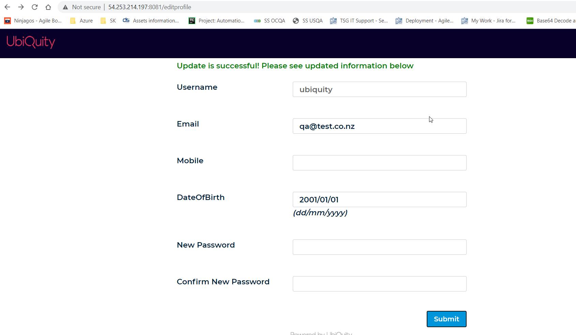

## **Bug-6**

**Name/Summary:** Insufficient text content in landing page

**Project Name:** Programme Backlog

**Issue Type:** Bug

**Description:** Welcome message is missing “Test” between “the Ubiquity

Tester” and “admin page”

**Priority:** Low

**Severity:** 4 - Trivial

**Steps to Reproduce:**

1. I am on login page from <http://54.253.214.197:8081>

2. I provide correct login credentials (e.g. username “ubiquity” and password “P@ss123#UbiQuity”)

3. I Click on Login Button on login page

**Expected Result:**

I should be direct to landing page with correct welcome message “Welcome to the Ubiquity Tester Test admin page.”

**Actual Result:**

I have been direct to landing page with wrong welcome message is “Welcome to the Ubiquity Tester admin page.”

**Asset:** Ubiquity Tester

**Assignee:**

**Reporter:** Whitney Li

**Environment:** test environment

**Versions:**

Release version – unknow

Browser - Google Chrome(86.0.4240.75) in windows10

**Attachments:**

Defect Image

